**NETWORK PACKET ANALYSIS USING WIRESHARK**

From the attached file “SBT-PCAP4”, carry out the following actions:

* What is the MAC address of the attacker?
* What is the type of attack which is taking place that allows the attacker to listen in on conversations between the central server and another host?
* What is the file which was downloaded from the central server?

**ANSWERS**

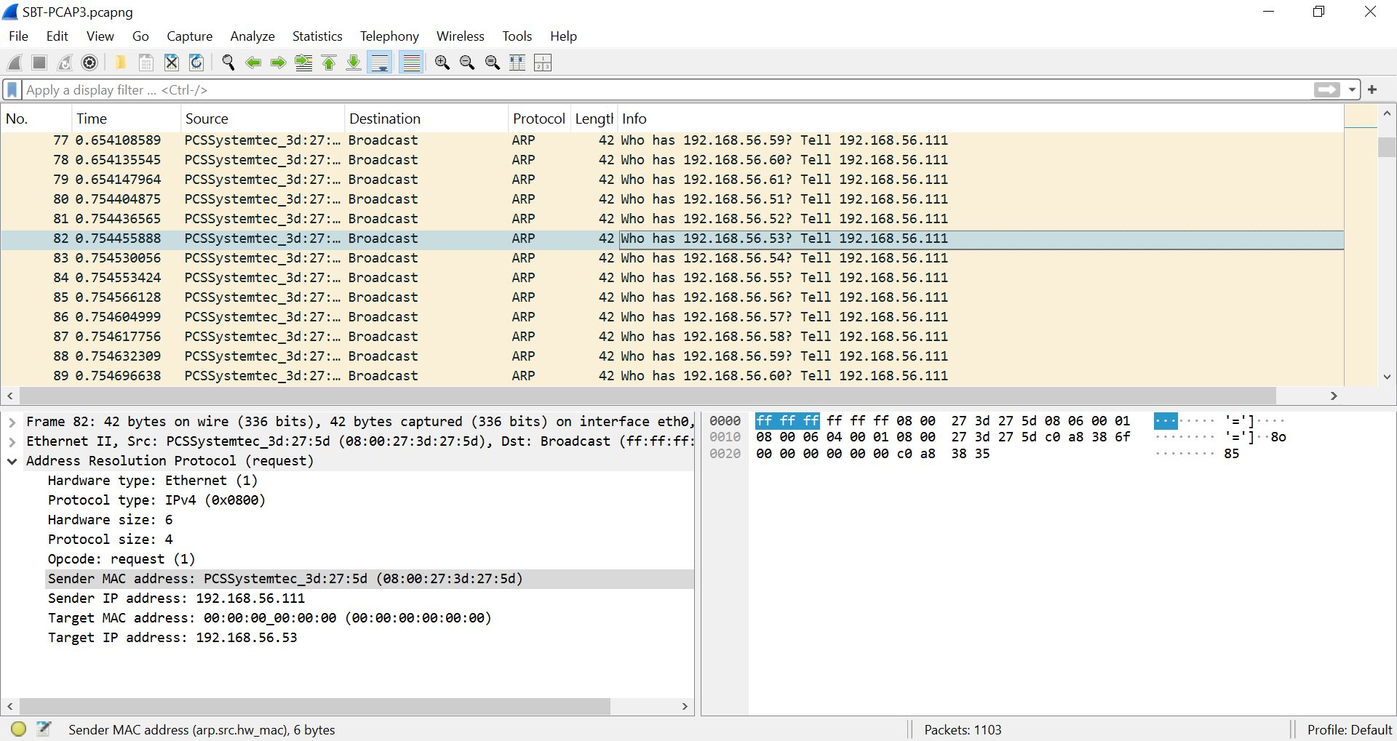

1. From the above packet analysis, this is the attacker’s MAC address **08:00:27:3d:27:5d**
2. The type of attack that was allowing the attacker to listen between the server and the host is called **Man In The Middle Attack.**
3. The name of the file that downloaded from the central server is called **Alevis_Employee_Information_Chart.csv**